System Design Document
Invisible Queue: A Real-Time Animated Queue Simulation and Wait-Time Prediction System

- Introduction

  - Purpose
This document describes the internal design and architectural structure of the Invisible Queue System. It translates the requirements defined in the Software Requirements Specification (SRS) into a structured implementation blueprint.

  - Scope
The design document defines:
- System architecture
- Module responsibilities
- Class structure
- Data flow
- Algorithm logic
- Runtime interaction behaviour
This document focuses on how the system will be built.

- System Architecture Overview

2.1 Architectural Style
The Invisible Queue System follows a layered modular architecture with clear separation of concerns.
The system is divided into five major components:
- Web UI Layer
- Simulation Engine
- Prediction Engine
- Decision Engine
- Animation Renderer

2.2 High-Level Architecture Flow
User
↓
Web UI
↓
Simulation Engine
↓
Prediction Engine
↓
Decision Engine
↓
Animation Renderer
↓
Web UI Output

Each module performs a single, well-defined responsibility

2.3 Design Principles
- Separation of concerns
- Mathematical correctness
- Modularity
- Real-time responsiveness
- Extensibility for future ML integration

3. Module Design

3.1 Simulation Module
Responsibility
Simulates queue behaviour using probabilistic arrival and service processes.
Inputs
- Arrival rate (λ)
- Service rate (μ)
- Current queue state
Outputs
- Updated queue length Q(t)
Core Functions
- Generate arrival event (Poisson approximation)
- Generate service completion event
- Update queue length

3.2 Prediction Module
Responsibility
Computes queue performance metrics using M/M/1 model.
Inputs
- λ
- μ
Outputs
- Utilization factor (ρ)
- Waiting time in queue (Wq)
- Total time in system (W)
- Expected queue length (L)
Mathematical Models Used
$$ρ=\frac{λ}{μ} \\ W=\frac{1}{μ-λ} \\ W_{q}=\frac{ρ}{μ-λ} \\ L=λW$$

3.3 Decision Module
Responsibility
Evaluates whether waiting in the queue is worthwhile.
Inputs
- Waiting time W
- Threshold time T_threshold
Output
- Decision score S
- Recommendation (Worth Waiting / Not Worth Waiting)
Decision Formula
$$S=α(T_{threshold}-W)$$
Decision rule:
If S > 0 → Worth Waiting
If S ≤ 0 → Not Worth Waiting

3.4 UI Module
Responsibility
- Accept user inputs (λ, μ, threshold)
- Display queue animation
- Display metrics (ρ, W, Wq)
- Display decision result
- Update interface every second

3.5 Animation Module
Responsibility
- Render animated service counter
- Render queue of clients
- Reflect real-time queue length
- Synchronize with simulation tick

4. Class Design

4.1 Class: QueueSimulator
Attributes:
- arrival_rate
- service_rate
- queue_length
- current_time
Methods:
- step()
- simulate_arrival()
- simulate_service()
- update_queue()

4.2 Class: PredictionEngine
Methods:
- calculate_utilization()
- calculate_waiting_time()
- calculate_queue_length()

4.3 Class: DecisionEngine
Methods:
- compute_score()
- evaluate_decision()

4.4 Class: AnimationRenderer
Methods:
- render_queue()
- render_metrics()
- update_display()

5. Data Design

5.1 Core Variables
- λ (arrival rate)
- μ (service rate)
- ρ (utilization)
- Q(t) (queue length)
- W (total waiting time)
- Wq (waiting time in queue)
- S (decision score)

5.2 Data Flow
- User inputs λ and μ.
- Simulation engine updates queue state.
- Prediction engine computes metrics.
- Decision engine computes recommendation.
- UI updates visual display.

6. Algorithm Description

6.1 Simulation Cycle
Step 1: Initialize λ and μ.
Step 2: At each time tick (1 second):
- Generate arrival event.
- Generate service completion event.
- Update queue length.
Step 3: Compute utilization and waiting time.
Step 4: Compute decision score.
Step 5: Update UI and animation.

7. Sequence Flow (Runtime Interaction)
User → Start Simulation
→ UI triggers Simulation Engine
→ Simulation Engine updates queue
→ Prediction Engine computes metrics
→ Decision Engine evaluates worthiness
→ Animation Renderer updates display
→ UI shows updated results

8. Design Constraints
- Single-server queue (M/M/1 model)
- Real-time update interval: 1 second
- λ must be less than μ for stability
- Queue size limited to realistic bounds (< 100)

9. Future Design Extensions
- Multi-server queue (M/M/c)
- Machine learning-based λ estimation
- Real-world sensor integration
- Cloud deployment

10. Class Diagram

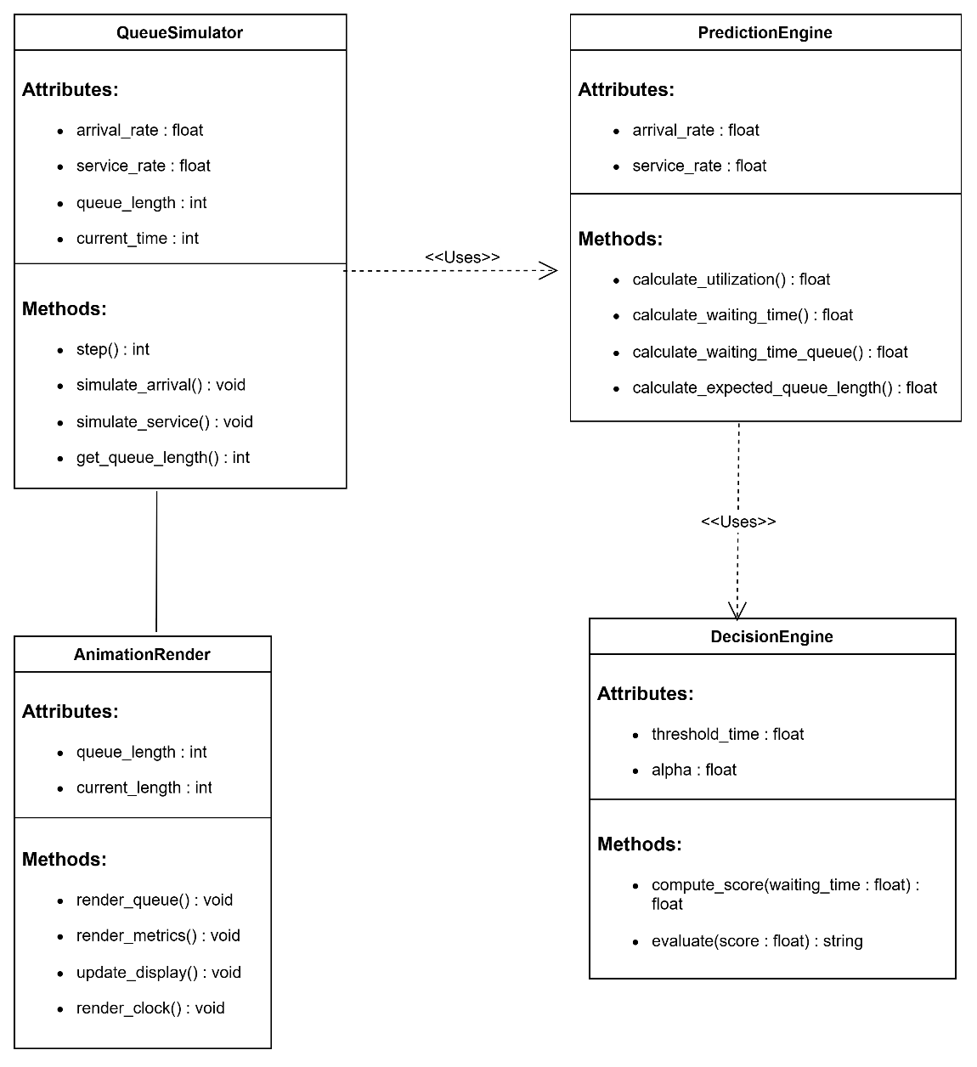

11. Sequence Diagram
